Daily Tarot App

Proposal

This app gives registered users a daily fortune based on traditional tarot card readings.

Wireframes

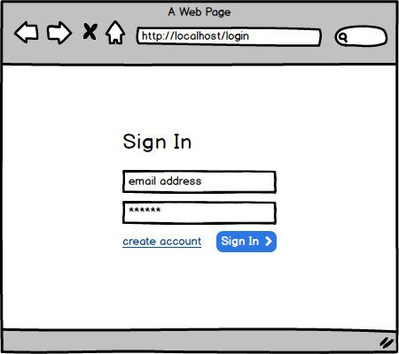

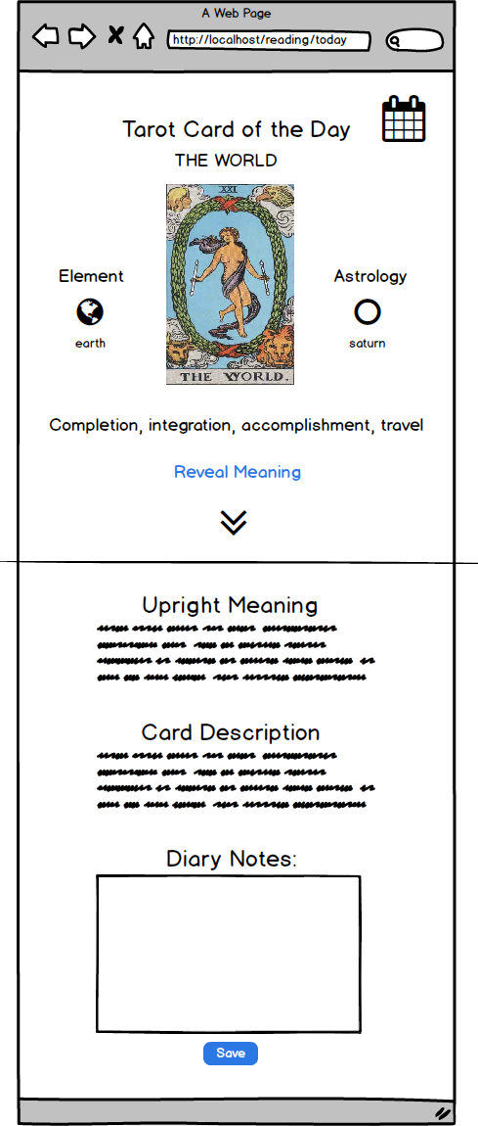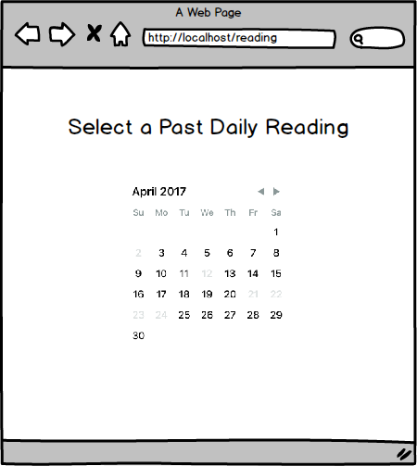

MVP

1. The app only draws cards for registered users.
2. Only one tarot card is drawn per day and saved to a user’s history.
3. The reading includes in-depth explanations for a card in the upright or reverse position.
4. The user can save a diary entry at the end of each day if they want to record their progress.
5. The user can recall their past readings using a calendar
6. DB design allows for phase 2 updates to integrate easily

Phase 2

* Ask for a reading based on a question
* Allow for multi-card spreads like the celtic cross.
* History based on question
* Glossary of cards
* Allow user to choose their preferred deck design